02-09-2021

COMPUTER NETWORKING LAB - EXP 7

**TCP FULL AND HALF DUPLEX IMPLEMENTATION**

TCP HALF DUPLEX SERVER CODE :

#include <unistd.h>

#include <stdio.h>

#include <sys/socket.h>

#include <stdlib.h>

#include <netinet/in.h>

#include <string.h>

#define PORT 8082

int main(int argc, char const *argv[])

{

int server_fd, new_socket, valread;

struct sockaddr_in address;

int opt = 1;

int addrlen = sizeof(address);

char buffer[1024] = {0};

char *hello = "reply from server";

if ((server_fd = socket(AF_INET, SOCK_STREAM, 0)) == 0)

{

perror("socket failed");

exit(EXIT_FAILURE);

}

if (setsockopt(server_fd, SOL_SOCKET, SO_REUSEADDR | SO_REUSEPORT,&opt, sizeof(opt)))

{

perror("setsockopt");

exit(EXIT_FAILURE);

}

address.sin_family = AF_INET;

address.sin_addr.s_addr = INADDR_ANY;

address.sin_port = htons( PORT );

if (bind(server_fd, (struct sockaddr *)&address,sizeof(address))<0)

{

perror("bind failed");

exit(EXIT_FAILURE);

}

if (listen(server_fd, 3) < 0)

{

perror("listen");

exit(EXIT_FAILURE);

}

if ((new_socket = accept(server_fd, (struct sockaddr *)&address,(socklen_t*)&addrlen))<0)

{

perror("accept");

exit(EXIT_FAILURE);

}

valread = read( new_socket , buffer, 1024);

printf("server waits for 5 seconds\n");

sleep(5);

printf("%s\n",buffer );

sleep(5);

printf("server waits for another 5 seconds\n");

send(new_socket , hello , strlen(hello) , 0 );

printf("reply to client sent\n");

return 0;

}

TCP HALF DUPLEX SERVER SCREENSHOT :

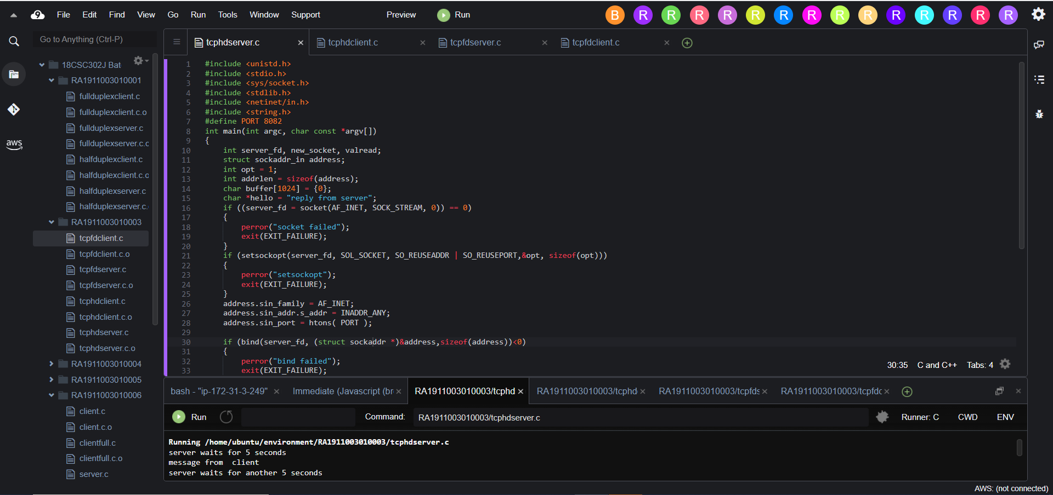

TCP HALF DUPLEX CLIENT CODE :

#include <stdio.h>

#include <sys/socket.h>

#include <arpa/inet.h>

#include <unistd.h>

#include <string.h>

#define PORT 8082

int main(int argc, char const *argv[])

{

int sock = 0, valread;

struct sockaddr_in serv_addr;

char *hello = "message from client";

char buffer[1024] = {0};

if ((sock = socket(AF_INET, SOCK_STREAM, 0)) < 0)

{

printf("\n Socket creation error \n");

return -1;

}

serv_addr.sin_family = AF_INET;

serv_addr.sin_port = htons(PORT);

if(inet_pton(AF_INET, "127.0.0.1", &serv_addr.sin_addr)<=0)

{

printf("\nInvalid address/ Address not supported \n");

return -1;

}

if (connect(sock, (struct sockaddr *)&serv_addr, sizeof(serv_addr)) < 0)

{

printf("\nConnection Failed \n");

return -1;

}

printf("reply in 5 seconds");

send(sock , hello , strlen(hello) , 0 );

printf("\n message sent\n");

valread = read( sock , buffer, 1024);

printf("%s\n",buffer );

return 0;

}

TCP HALF DUPLEX CLIENT SCREENSHOT :

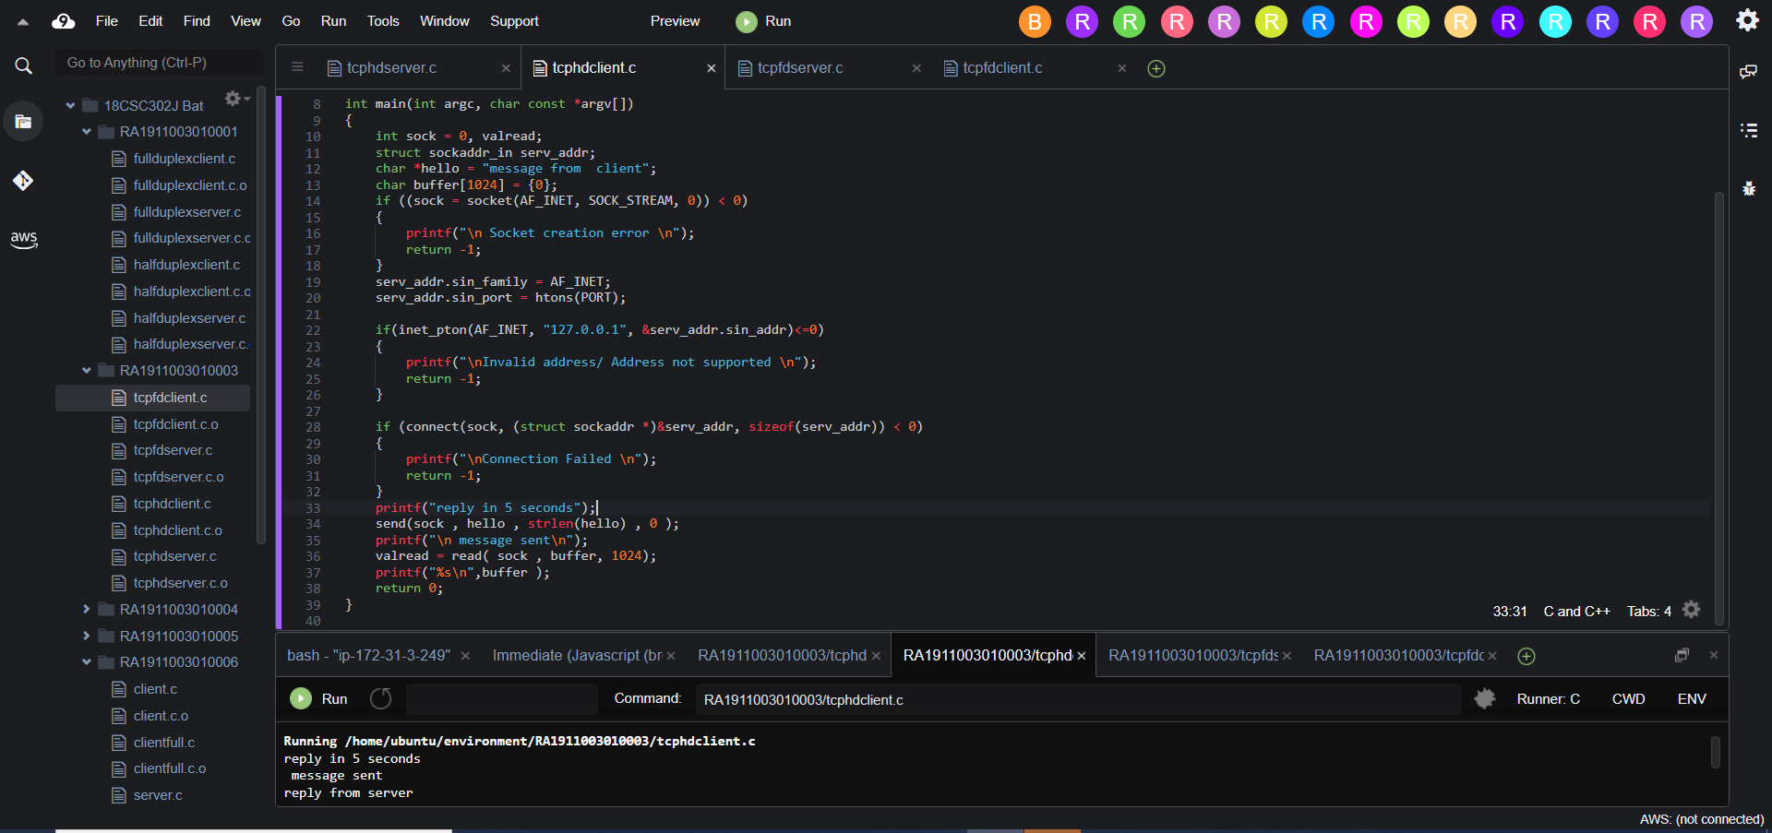

TCP FULL DUPLEX SERVER CODE :

#include <unistd.h>

#include <stdio.h>

#include <sys/socket.h>

#include <stdlib.h>

#include <netinet/in.h>

#include <string.h>

#define PORT 8056

int main(int argc, char const *argv[])

{

int server_fd, new_socket, valread;

struct sockaddr_in address;

int opt = 1;

int addrlen = sizeof(address);

char buffer[1024] = {0};

char *hello = "Hello from server";

if ((server_fd = socket(AF_INET, SOCK_STREAM, 0)) == 0)

{

perror("socket failed");

exit(EXIT_FAILURE);

}

if (setsockopt(server_fd, SOL_SOCKET, SO_REUSEADDR | SO_REUSEPORT,&opt, sizeof(opt)))

{

perror("setsockopt");

exit(EXIT_FAILURE);

}

address.sin_family = AF_INET;

address.sin_addr.s_addr = INADDR_ANY;

address.sin_port = htons( PORT );

if (bind(server_fd, (struct sockaddr *)&address,sizeof(address))<0)

{

perror("bind failed");

exit(EXIT_FAILURE);

}

if (listen(server_fd, 3) < 0)

{

perror("listen");

exit(EXIT_FAILURE);

}

if ((new_socket = accept(server_fd, (struct sockaddr *)&address,(socklen_t*)&addrlen))<0)

{

perror("accept");

exit(EXIT_FAILURE);

}

valread = read( new_socket , buffer, 1024);

printf("%s\n",buffer );

send(new_socket , hello , strlen(hello) , 0 );

printf("Hello message sent\n");

return 0;

}

TCP FULL DUPLEX SERVER SCREENSHOT :

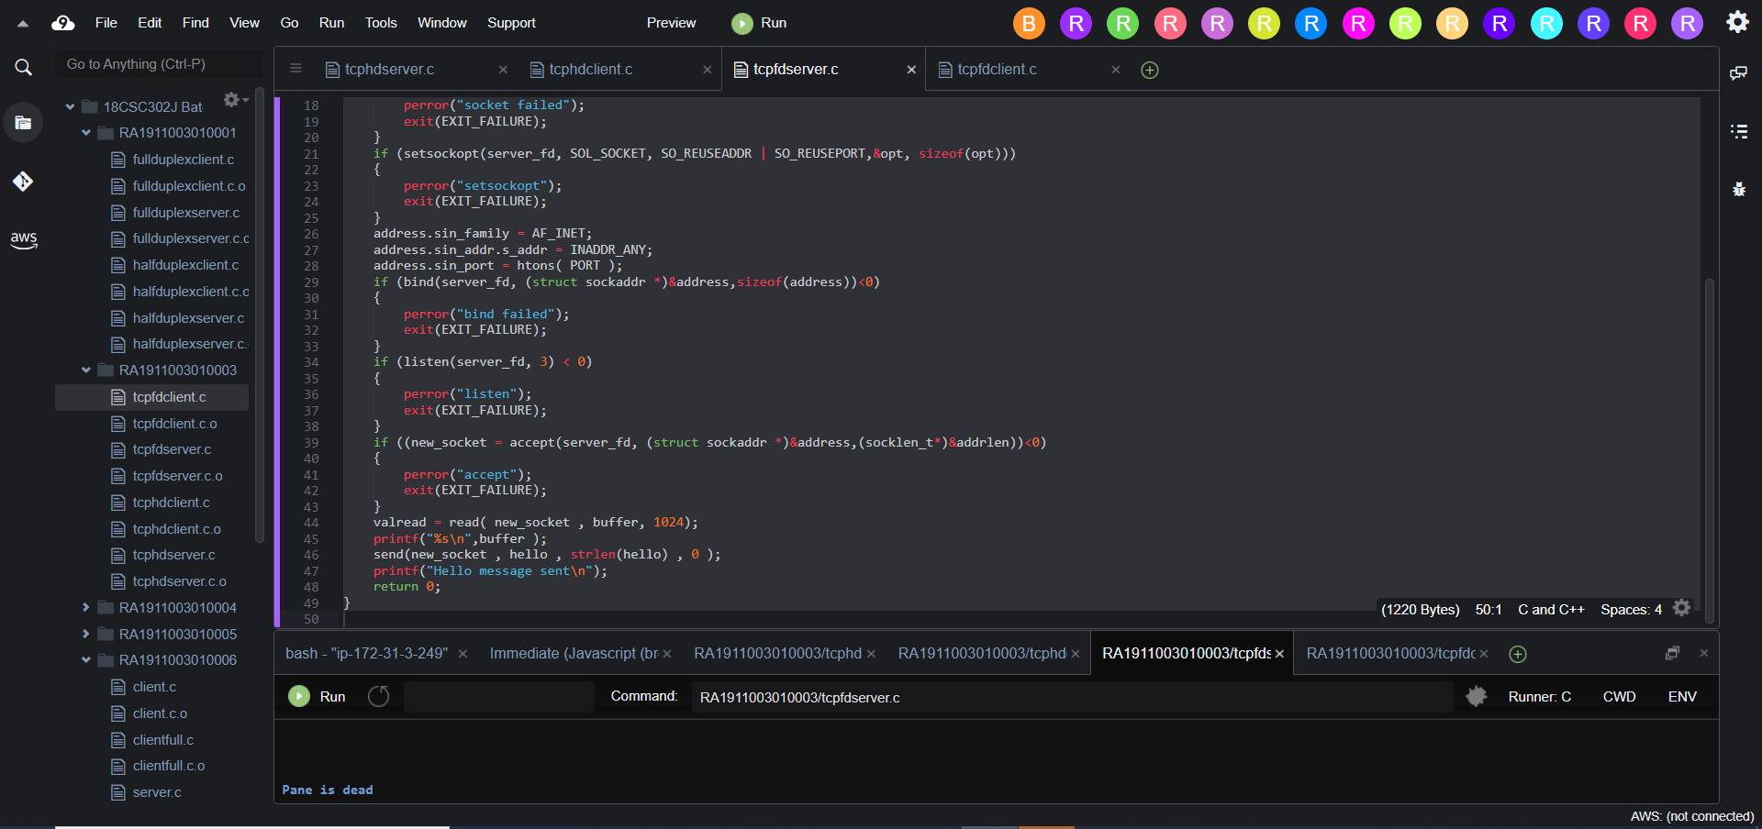

TCP FULL DUPLEX CLIENT CODE :

#include <stdio.h>

#include <sys/socket.h>

#include <arpa/inet.h>

#include <unistd.h>

#include <string.h>

#define PORT 8056

int main(int argc, char const *argv[])

{

int sock = 0, valread;

struct sockaddr_in serv_addr;

char *hello = "Hello from client";

char buffer[1024] = {0};

if ((sock = socket(AF_INET, SOCK_STREAM, 0)) < 0)

{

printf("\n Socket creation error \n");

return -1;

}

serv_addr.sin_family = AF_INET;

serv_addr.sin_port = htons(PORT);

if(inet_pton(AF_INET, "127.0.0.1", &serv_addr.sin_addr)<=0)

{

printf("\nInvalid address/ Address not supported \n");

return -1;

}

if (connect(sock, (struct sockaddr *)&serv_addr, sizeof(serv_addr)) < 0)

{

printf("\nConnection Failed \n");

return -1;

}

send(sock , hello , strlen(hello) , 0 );

printf("Hello message sent\n");

valread = read( sock , buffer, 1024);

printf("%s\n",buffer );

return 0;

}

TCP FULL DUPLEX CLIENT SCREENSHOT :

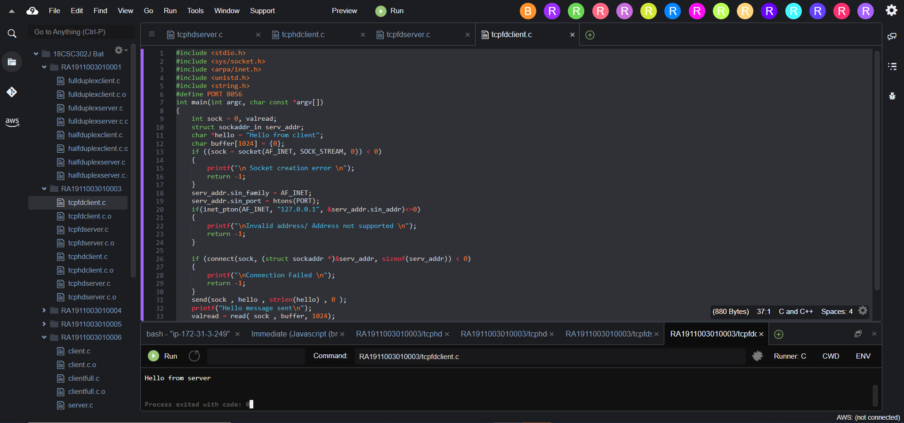

DONE BY :

ABHINAV RANJAN

RA1911003010003

CSE A1 SECTION

SRMIST , KTR